Kingston: Technology and the Heritage Tourism Product
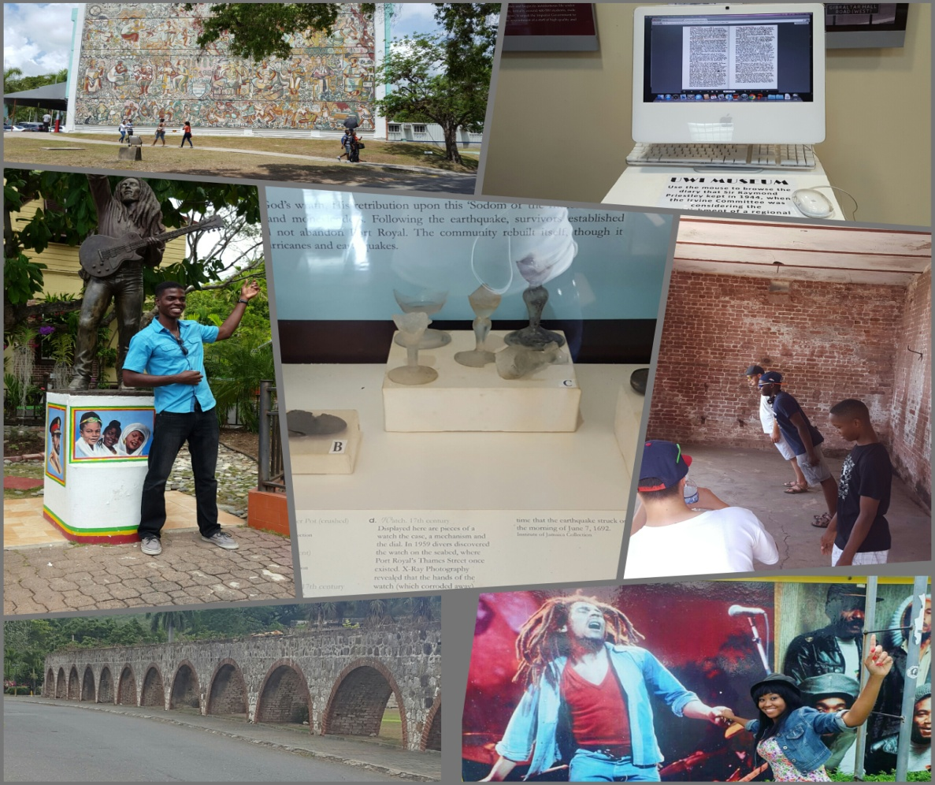

The University of the West Indies
Students: Melanie Taylor
Mishica Bonner
Advisor: Eritha Huntley Lewis

TABLE OF CONTENTS

Introduction 3
Glossary of Terms 5
Problem Statement 6
Objectives 7
Delimitations and Limitations 8
Literature Review 9
Methodology 22
Sample 22
Data Collection 22
Description of Research Instrument 23
Treatment of Data 23
Analysis of Findings 24
Discussion 34
Recommendations 37
Conclusion 41
References 42
Appendices 46

Introduction
‘We likkle but we tallawah,’ is a saying used by many in Jamaica, which means, we may be small in size but we have so much to offer as we are a strong and courageous set of people. Jamaica is the 3rd largest island in the Caribbean with a culture that is as diverse as the number of ethnic groups that reside in the country. Since gaining Independence on August 6, 1962, from the British, the country has made significant progress, especially in areas such as music and sports. Of note are the accomplishments of Robert ‘Bob’ Marley and Usain Bolt, nine times Olympic gold medalist.
Tourism is Jamaica’s second largest foreign exchange earner. The total stopover arrivals in 2015 exceeded the 2 millionth mark to reach a record of 2,123,042, which was 2.1% above the 2,080,181 arrivals recorded in 2014 (JTB, 2014). The island is predominantly known for its white sand beaches and was marketed by three primary tenets: the sun, sand and sea. Tourism development has been focused on popular resort areas, namely Montego Bay, Negril and Ocho Rios. Despite the focus on beach-based tourism experiences, Jamaica has a tremendous heritage that could be used to complement the existing tourism product. This would support the currently thrust in tourism marketing that focuses on the three E’s: education, entertainment and excitement.
Jamaica’s heritage encompasses the identity of the indigenous people, the Tainos; the Spanish and the English who established settlements and plantations; and a number of ethnicities including the Africans, who arrived in Jamaica as slaves, and are now the largest ethnic group on the island. The Chinese, Indians, Germans, Jews, Syrians/Lebanese, who arrived in Jamaica as indentured servants, have also contributed to Jamaica’s cultural heritage. Our motto “Out of Many One People” captures the dynamic nature of Jamaica’s heritage and culture.
One location on the island that showcases this, is the resort area of Kingston. It is the hub of trade and commerce, as well the smallest parish and the seat of Jamaica’s government. It is also the home of reggae music and the epicenter for education, sports and other social and economic activities on the island. Kingston is often referred to as the cultural capital of the Caribbean and promoted as “the heartbeat of Jamaica” (Jamaica Tourist Board, 2016). Of note, Kingston gained membership to United Nations Educational Scientific Cultural Organization (UNESCO) Creative Cities Network in music. The Blue and John Crow Mountains were added to UNESCO’s list beneficial to Kingston. With greater level of development, Kingston’s legacy can be better protected with the area becoming the preferred heritage destination in Jamaica.

Glossary of Terms
- Culture is “inherited” through transmission and education from generation to generation so both culture and heritage are dynamic concepts (Bonarou, 2011).
- Heritage is defined as all remains and objects and any other traces of mankind and its relation to the natural environment on land or underwater (Trotzig, 1993).
- Sustainable development is development that "meets the needs of the present without compromising the ability of future generations to meet their own needs." (World Commission on Environment and Development, 1987)
- Technology is defined as any tool or technique: any product or process, any physical equipment or method of doing or making by which human capability is extended. (Schon, 1967)
- Tourism comprises the activities of persons travelling to and staying in places outside of their usual environment for not more than one consecutive year for leisure, business and other purposes. (UNWTO)

Problem Statement/Rationale
Heritage tourism has the potential to diversify Jamaica’s tourism product. This type of tourism has the ability to re-brand tourism in Jamaica beyond the attractions and activities found in the popular resort areas. Kingston is vital in promoting heritage tourism in Jamaica. The purpose of this study is, therefore, to determine how technology can be used to enhance and sustain heritage tourism in Kingston, Jamaica. The approach taken will focus on three main aspects of heritage. These are educational, music and historical heritage. To represent these pillars are the University of the West Indies, Mona, Bob Marley Museum and Fort Charles in Port Royal will be examined. These sites showcase their heritage mainly through guided tours with the aid of screens showing short documentaries, video clips and pictures taken during the time history was being created. These are limited however, and can be further developed thus, increasing their attractiveness to visitors. For example, The University of the West Indies uses screens to show some documents to avoid visitors touching them, thus, eliminating physical damages to our valuable artifacts. Whereas, at Bob Marley museum a short documentary is shown at the end of the tour and so persons are able to see what his life was like and his achievements. However, at Port Royal most of the artifacts or monuments can be seen on the outside such as, canons, the giddy house and so persons will be able to come in contact with them more.

Objectives
The objectives of this case study research are to:
- Evaluate Kingston’s potential as a heritage attraction.
- Examine how Kingston’s heritage is interpreted at the named sites.
- Assess how technology can assist in ensuring the sustainability of Kingston heritage product.

Delimitations and Limitations
Jamaica has several heritage tourism attractions but for this case study, we focused on three attractions in the Kingston resort area. The study does not intend to focus on attractions outside of the Kingston resort area. Though there are many heritage attractions in Kingston, it will also on examine three attractions. No attempt will be examine issues relating to the management of these attractions. The researcher only intends to examine how heritage is displayed and how technology can be used to sustain these attractions.

Several limitations were faced, mostly with obtaining information for each site. The research was very time consuming and the researchers had limited time to collect data from each attraction. It was also difficult to ascertain which days were best to get the largest sample of visitors and to meet with the relevant interviewees. The researchers had to visit each attraction more than once since the operators to be interviewed were not always present on the days chosen to complete the visitor surveys. It was also costly to travel to each attraction, contact each by phone and to print questionnaires.
Literature Review
What is Heritage?
Heritage is defined as all remains and objects and any other traces of mankind and its relation to the natural environment on land or underwater (Trotzig, 1993). This definition gives the impression that heritage is only material reminders. However, it was also defined as a set of attitudes to, and relationships with the past by (Walsh, 1992; cited by Smith, 2006). This definition clarifies that heritage is anything that identifies a people. This heritage, moreover, was associated with the more distant past, implicating castles, plantation great homes, battlefields, old churches and similar historical phenomena as significant cultural inheritances worthy of protection and mal-presentation (Yale, 1991). There have been many definitions and interpretations of the word ‘heritage’. Perhaps the most commonly accepted definition among heritage scholars has at its core ‘the present day use of the past’ (Ashworth, 2003; Graham et al., 2000 cited by Timothy & Boyd, 2008). There are different elements of heritage, these are cultural (Richards, 1996), natural (Hall, 2000) and built (Laws, 1998). The term ‘heritage’ and ‘culture’ are used interchangeably (Christou, 2005). A culture is “inherited” through transmission and education from generation to generation so both culture and heritage are dynamic concepts (Bonarou, 2011).

Relationship between Heritage and Tourism
Heritage tourism is defined as people travelling to experience another person’s culture and natural resources to see artefacts, monuments and stories of both past and present that is authentic (National Trust for Historic Preservation, 2011). Heritage tourism is commonly regarded as activity by tourists in a space where historic artifacts are presented (Garrod & Fyall, 2001). The World Heritage Association defines heritage tourism as, an immersion in the natural history, human heritage, the arts and philosophy and the institutions of another region or country. Heritage tourism is often referred to as cultural heritage tourism (Cultural Heritage Tourism 2014). This form of tourism provides an opportunity for people to experience their culture in depth, whether by visiting attractions, historical or culturally relevant places, or by taking part in cultural activities (Cultural Heritage Tourism, 2014).

The capitalization of the cultural heritage represents an important driver for development, including the tourism activities in a specific area. When properly managed, it can enhance the livability of their surrounding areas and sustain productivity in a changing global environment (Pereira Roders & van Oers, 2011). As the term implies, cultural heritage tourism involves visiting places that are significant to the past or present cultural identity of a particular group of people (Cultural Heritage Tourism, 2014). Objects of historical and cultural heritage, being an important asset of the cities, may profit and significantly influence their economic development. (Gulnara & Lenar 2015) For example, a study by the Travel Industry Association in 2003 shows that, heritage travelers stay longer at their destinations and spend more money there than other types of travelers.

Types of Heritage Tourism
There are different aspects of heritage tourism that represents different elements of a nation’s material and immaterial culture and heritage. Of note, is the built heritage which is a complex term used in relation to the preservation of monuments and historic building that are now being used in tourism (Nuryanti, 1996). There is an interrelationship between nature and culture with regards to built heritage since both in congenial settings enhance each other, even though built heritage is seen more as related to culture than to nature according to Nuryanti, 1996. In addition, nature-based tourism is sometimes used independent of heritage tourism but there is a strong relationship between both. For example, many heritage nature trails exist throughout the world at many different scales and sizes (Cheung, 1999; Prideaux, 2002; Sevigny, 1992 cited by Timothy & Boyd, 2008).

Displaying Heritage Products
According to Dean McCannell (1989) tourist attractions are, in fact, signs that represent something to someone (Palmer 1998). How a nation presents these symbols and how the world sees them are very important factors that contribute to how heritage is used as a tourism product. O’Conner, 1993 (cited by Palmer, 1998) argues that identities, both personal and individual, were developed through interaction with others and [influences] how we are perceived and treated by them. This is also the same for our national and cultural identities; how we see ourselves is determined by how others see us (ibid, 1993). Heritage tourism products are packaged then to attract both overseas and local visitors. Some countries heritage tourism attractions are designed specifically for domestic tourists, while others are geared at overseas visitors. For example, aspects of Ireland’s heritage are designed specifically to attract overseas visitors. The country is thus represented as a sort of pre-modern society ‘...a country of ‘shamrocks’...and leprechauns...a place of picturesque scenery an unspoiled beauty, of friendly and quaint people, a place which is steeped in past traditions and ways of life’, in a sense a country that is in no particular hurry to catch up with the modern world (O’Conner, 1993, p. 68).
Some attractions not just focus solely on the past, but also on the present. This is so at the Brighton Fishing Museum in the U.K that combines the past with the present. The museum is located on Brighton’s seafront, next to the ‘arches’ used by present day ﬁshermen for repairing nets, boats and equipment. The visitors cannot only view the old photographs, boats and artefacts from Brighton’s ﬁshing history, but they can also watch the ﬁshermen carrying out the same type of activities described in the museum. The local ﬁshermen explained how their work attracts considerable attention as visitors like to see them employing the type of skills that seem to epitomise what has been lost by today’s fast-paced, hi-tech society (Palmer, 1998).

Managing Heritage Tourism Sustainably
Tourism will never be completely sustainable as every industry has impacts, but it can work towards becoming more sustainable (Sustaining Tourism, 2014). Economic development, social development and environmental protection are interdependent and mutually reinforcing components of sustainable development (Bayley & Strange, 2008). Sustainability is the use of resources to meet the needs of the present without compromising the needs of future generations (WCED, 1987). In managing heritage tourism products, sustainable practices and measures needs to be in place to ensure that it is being preserved, while being profitable and meeting the social requirements of both the tourists and the locals. It has been recognized that the ideological and institutional context of heritage tourism is fundamentally different from that of general tourism in that the ‘curatorial approach still pervades the heritage sector according to Leask and Goulding (1996). This means that consideration for public access is made second to that of maintaining the site in its pristine state. As a result, much focus is not placed on the economic viability of the site but its preservation. This has led to concerns regarding maintaining and repairing these sites/attractions that mostly depend on access to traditional sources of public funding that has been restricted by successive government spending cuts (Garrod and Fyall, 2000)
Together with other forms of capital – physical, natural, economic, human, social, and organizational, the cultural heritage represents one of the major resources that can be employed in order to support the sustainable development (Svendsen and Sørensen, 2007). Culture, cultural heritage and development have been making an incalculable contribution toward improving human livelihoods and well-being in lasting and sustainable ways (Bandarin et al., 2011). UNESCO in 2011 implemented a number of guidelines in place as to how to sustain heritage tourism, preserve cultural and historical assets and safeguarding our environment, not just at a local level but also internationally. The key goal of the programme is to strengthen the enabling environment, developing strategies through stakeholder engagement for the planning, development and management of sustainable tourism and focuses on empowering local communities (UNESCO, 2011).
Heritage Tourism in Jamaica
Bob Marley Museum
Born on February 6, 1945, in St. Ann Parish, Jamaica, Bob Marley helped introduce reggae music to the world and remains one of the genre's most beloved artists to this day (Bibliography, 2016). Arriving in Kingston in the late 1950s, Marley lived in Trench Town, one of the city's poorest neighborhoods. He struggled in poverty, but he found inspiration in the music around him (Bibliography, 2016). Robert Nesta Marley was the first and possibly the only superstar to emerge from the third world (Mosowitz, 2007). His commitment to the Rastafarian faith and his views on social issues were the cornerstone of his music. His song ‘One Love’, which speaks to his hope for world peace and his position on equality for all races, classes and ethnicities, is depicted on the track ‘War’ (Jamaica Information Service).
In late 1963, the Wailing Wailers was formed, which consisted of Bunny Wailer (Neville Livingston), Peter Tosh (Winston Hubert), Bob Marley and later on Beverly Kelsoe, Cherry Smith and Junior Brathwaite (Collingwood, 2006). Their first single, "Simmer Down," went to the top of the Jamaican charts in January 1964 (Collingwood, 2006). In 1970, the Wailers forged a relationship with Lee Scratch Perry, the album; “Soul Rebel” was released in the United Kingdom. By 1976, He was regarded as a global reggae ambassador.
Throughout his lifetime and after his death Bob has received some recognition in Jamaica and a number of international awards. These include: German Record award for ‘Natty Dread’ 1979; the Peace Medal of the Third World from the United Nations, June 1978; The Order of Merit in 1981 which is the third highest honor; Centenary Medal from the Council of the Institute of Jamaica, 1970 and 1979 (Jamaica Information Services). Three decades after his death, the revolutionary Tuff Gong Rastaman is now completely made over and repackaged as the poster boy for the Jamaican tourist industry (Cooper, 2011). Bob Marley’s legacy lives on and people are constantly reminded of him through his music and the yearly celebration of his birthday at the Bob Marley Museum.
The life and achievements of internationally acclaimed musical legend and Rastafarian luminary Robert Nesta Marley have been kept alive through artefacts, memorabilia, writings and photographs enshrined at his former residence and studio at 56 Hope Road in St Andrew (The Gleaner, 2015) which is now a museum. A recording studio can be found on the inside where his sons record some of their songs. The tour of the museums lasts approximately an hour and a 20 minutes film is shown at the end of the tour. It shows a very personal view of Bob’s life and the history and philosophy of his music (Bob Marley Museum website). "How come they charge US$20 for a ticket worth US$50?" asked one visitor, another item ticked off as an achievement on his 'bucket list' (The Gleaner, 2015). On May 31, 2001, the Bob Marley Museum declared a protected National Heritage site in Jamaica.

Port Royal
When the Spanish arrived in Jamaica in the 1500s, they thought that the cay was the ideal spot for careening, that is, a place to clean and refit boats scrape the hulls clean. They named the area, Cayo de Carena (United Nations Educational Scientific Organisation, 2009). When the British invaded Jamaica in 1655, immediately realising its strategic importance, they started to put fortifications in place (Jamaica National Heritage Trust). After 1670, the importance of Port Royal and Jamaica to England was increasingly due to trade in slaves, sugar, and raw materials. It soon became the mercantile center of the Caribbean area, with vast amounts of goods flowing in and out of the port through an expansive trade network (Hamilton, 2000). Privateering was becoming so attractive to colonists that merchant-ships and plantations were suffering from a shortage of labour (United Nations Educational Scientific Organisation, 2009).
From the wickedest city on earth to a thriving commercial centre of the new world, Port Royal Jamaica has been the subject of much popular interest (National Museum of Jamaica, 2010). The English captured Port Royal and there were pirate raids. Port Royal was shaken by an earthquake on June 07, 1962 and since then the wickedest city on earth was no longer (Jamaica National Heritage Trust, 2011). The tremors rocked the sandy peninsula on which the town was built, causing buildings to slide and disappear beneath the sea. An estimated 2000 Port Royalists were killed immediately in the disaster. Many more perished from injuries and disease in the following days (Hamilton, 2000).
Fort Charles, built in 1656, which is the oldest fort in Jamaica, one of six located in Port Royal, served to guard the entrance to the Kingston Harbour. It was the only one of Port Royal’s forts to survive the 1692 earthquake (Jamaica National Heritage Trust) The Fort Charles Museum is located on the original Fort Charles military compound at Port Royal, Jamaica (National Museum Jamaica, 2010). The “Giddy House” is a former artillery store built in 1888, a lopsided building; it was named so because the earthquake shifted it to its present 45 degree angle (Jamaica National Heritage Trust). In 1951, hurricane Charlie wiped out buildings but the Old Naval Hospital remained intact and provided a safe home for almost the entire population. (National Museum Jamaica)
Today, it is a heritage site that is recognised by United Nations Educational Scientific and Cultural Organisation (Jamaica National Heritage Trust, 2011). Port Royal is situated on the end of an 18-mile long sand spit known as the Palisadoes, 15 miles from the centre of Kingston, capital of Jamaica. Currently, the peninsula is one continuous strip although at various times throughout its history, the tip on which Port Royal stands was a cay completely surrounded by water. (United Nations Educational Scientific Organisation, 2009) Today with the warships and the soldiers gone, Port Royal has become a quiet fishing village, but it is one of the most important historical and archaeological sites in Jamaica (Jamaica National Heritage Trust, 2011)

The University of the West Indies, Mona
The University of the West Indies, Mona is now on the site of what was the Mona and Papine Estate in the mid-1700s. This is now a neighborhood in the southeastern section of the parish of St. Andrew which is about 8 kilometres from Kingston. Mona's owner, who was consolidating land holdings in this area, owned Papine Estate by the 18th Century, and in the 1920's these lands were purchased by the Kingston Water authorities for their controlled water rights. From the plantation era, UWI Mona has several remnants of great historical value such as the ruins of the aqueducts, Papine Estate Sugar Works, the old Mona Estate ruins.

In 1940 during World War II, the Estate was used as the evacuation camp for war threatened refugees from Gibraltar and Malta. The Mona Estate, which was at the time a government property located close to the city of Kingston was ideal and spacious enough to accommodate between 7,000 and 9,000 victims (Torello, 2005). Roads, barracks, stores, churches, a hospital, a police station and other infrastructure were also developed in the area. According to Torello, (2005) the refugees were monitored by Catholic nuns and priests but were able to leave the camp between 8am and 10pm daily once they logged in and out.

Jamaicans were able to enter the property once they had a pass; without this they would be fined. English Commander Major Henry Simms was the first to run the camp and his residence is one of the few buildings still standing from this era. Locals were employed at the camp and by the year before the war ended there was up to 186 local staff members (Torello, 2005). The war ended in 1944 and the refugees along with local women who got married were said to have left on one big ship.
The now University of the West Indies, situated on 653 acres of rich heritage and culture, was initially known as the University College of the West Indies. It began in 1948 as College of the University of London with 33 medical students. The Mona site was chosen because it was very spacious and still had facilities from the Gibraltar camp to accommodate students. It was also recommended by the Irvine Commission. In 1962, the University achieved independent degree granting status and is today the Caribbean's’ premier educational institution (Torello, 2005). Several signs and monuments from each era are still visible across the campus and remind visitors of this campuses rich history. History is still being created and new monuments are also being added to the campuses heritage and increasing its offerings for its Campus Culture and Heritage Tours.

Methodology
The paper was completed using a case study approach that focused on heritage tourism in Kingston, Jamaica. Desk research was done first to identify the heritage products as well as to understand what heritage tourism means and how technology can be used to sustainably develop the product. For all three attractions chosen, the study was done during the months of July and August 2016. These months are in one of Jamaica’s two peak seasons when there is an increase in visitors to the country. Each attraction was visited during the afternoon when the numbers of visitors were highest.
Sample
A convenient sample of fifteen visitors was selected from each attraction. The ones selected were from different age groups and nationalities to represent different groups’ views on the attractions, their experience and recommendations. A purposive sampling approach was also used to select staff to be interviewed at each attraction. These persons were selected because of their expertise and their ability, as a result of their job titles, to provide information relevant to this study. Three members of staff, including tour guides and site managers, were questioned at the three attractions to obtain information on current operations, challenges faced and short term strategies to enhance and sustain the attractions with the aid of technology.
Data Collection
Field trips were taken to the Bob Marley Museum, Port Royal and University of the West Indies, Mona. The researchers focused on the UWI Museum and Campus Culture and Heritage Tours, Fort Charles in Port Royal and the operations of the Bob Marley Museum. A survey was administered at each attraction to gather information on tourists experience and their perceptions on the subject of this study. Questionnaires were also used along with face to face and telephone interviews with managers and curators at the attractions to gather data on the management of the heritage products and how technology is being used and will be used at these attractions.
Description of Research Instrument
Two instruments were administered; one to the visitors that contained 16 questions and the other to the staff members at the attractions, containing 17 questions. The visitors’ questionnaire was designed to gather information on who visits, their gender, nationality, how many times they visit, how they found out about the attractions, description of the experiences, observation, their recommendations and whether or not they would revisit. The interview questions for staff were geared at obtaining information on the number of and types of visitors received, how these heritage attractions are interpreted and showcased, how technology is being used, challenges faced at the attractions and strategies being used to enhance and sustain these attractions with the aid of technology. These questions have helped to assess Kingston’s heritage tourism potential in identifying the types of visitors these attractions receive, how they feel about their experience and how these attractions can be sustainably developed and enhanced with the aid of technology.
Treatment of the data
The information collected was tabulated using Microsoft Excel and displayed in graphs to provide a pictorial representation of the data. The main objective of the assessment of the data was to determine how the visitors and staff at the attractions felt about the research topic. Every effort was made to protect the identity of the respondents and to ensure that the results were valid.
Description of Findings
The Potential of the three Attractions as a heritage site:
The resort area, Kingston, is very diverse in its offerings and helps to showcase Jamaica’s past through its many heritage sites. There are a number of historical monuments and institutions visible throughout Kingston, several of which are currently being used as tourist attractions. Three significant attractions are Bob Marley Museum, Port Royal and the University of the West Indies, Mona that are helping to show, through visitors’ feedback, Kingston’s potential as a heritage attraction.
Bob Marley’s Museum and Port Royal both receive over 3,000 visitors per month while the University of the West Indies currently receives approximately 300 visitors per month. Of the persons who visit these sites, 54% women, while 46% of the total respondents for all three attractions are male.
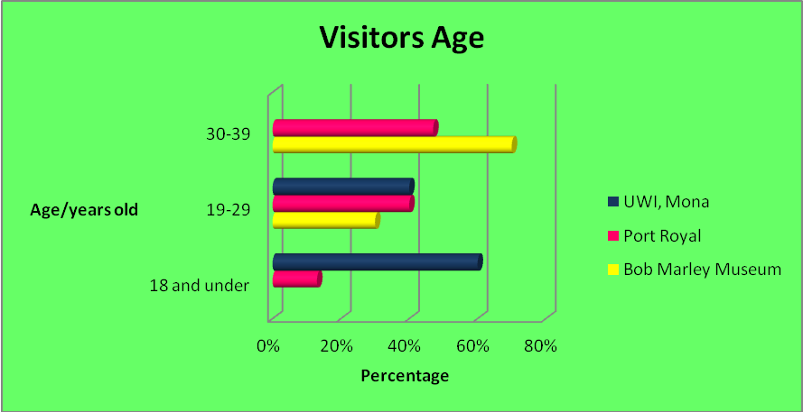
For UWI, Mona, 60% of respondents were young adults ages 18 and under while the remaining 40% were in the 19-29 age group. For Port Royal, 13% of the respondents were 18 years old and younger, 40% are 19-29 years old and the remaining 47% are over 40 years old. The respondents at the Bob Marley Museum were ages 19-29 (30%) and 30 to 39 (70%).
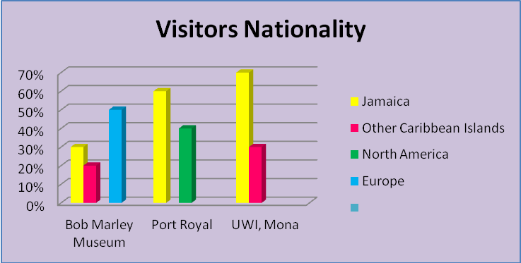
Of the persons questioned, 60% of Port Royal’s respondents were local residents while the remaining 40% are from North America. The Bob Marley’s museum had approximately 30% local respondents as well as visitors from within the other Caribbean islands (20%) and Europe (50%). UWI, Mona’s respondents are mostly locals (70%) and regional students (30%).
When asked how often they visit cultural/heritage attractions, 86% of the visitors at Port Royal visit cultural/heritage attractions at least 1-2 times per year while the remainder visits 3-4 or even 5 times. This is similar for Bob Marley museum and UWI Mona. However, visitors to UWI, Mona have a higher percentage of visitors who visit other heritage attractions each year where approximately 33% visit culture/heritage attractions 3 or more times per year. 60% of the respondents were visiting Bob Marley Museum and Port Royal for the first time. UWI, Mona had 6% more visitors who were first time visitors.
80% of visitors to Marley Museum and Port Royal found out about these attractions through family and friends. For UWI, Mona, on the other hand, 80% found out about this attraction in school. The internet, radio and TV accounted for 20% as source of information on these sites.
Jamaica’s heritage is interpreted in different ways at each attraction that showcases different aspects of our material and immaterial culture and heritage.

How are these heritage attractions interpreted and promoted?
Upon entering, the Bob Marley Museum, one can hear reggae music playing softly in the cafe located at the property’s entrance. This café offers various food and beverage options. TV screens are strategically used to display the menu and to give information about different parts of the property. The cashiers who collect the entrance fees are located next to the café. A statue of Bob Marley sits prominently in front of the house between statues of 2 lions; one to the left and the other to the right. Visitors are given guided tours to different parts of the property. The grounds’ picket fences have paintings in Rastafarian colors; red, gold and green and has murals and paintings of Bob Marley, his band and family on the perimeter walls.
Of note, The Bob Marley Museum is one of three (3) tours offered by the Bob Marley Brand. The other tours offered are of Tuff Gong Studios and Bob Marley’s burial site at Nine Mile, St. Ann. The main site visited is the Museum on Hope Road where he lived. The Tuff Gong studio which is located approximately 5.8 kilometers away from the museum also has visitors who are mostly persons with in depth interest in creating music. Nine Miles in St. Ann where he grew up and was also laid to rest is approximately 100 kilometers away from the museum on Hope Road and mostly sees visitors during his birthday celebration in February each year.
The tours are standard and there is not much variation for different age groups and focus groups that visit. The tour guides will however, use different styles or place more focus on specific aspects when necessary.
Similarly, in Port Royal, tours are also tailored by the tour guides to match the needs of different groups. For example, if there is a group of children, the tour starts with a simple story whereas, adults with prior knowledge are given more in-depth details.
Port Royal which showcases mostly aspects of Jamaica’s built heritage, is now a small community at the end of the Palisadoes Strip in the resort area of Kingston. On entering the area one can see buildings of ancient European architecture. There is a metal sign welcoming visitors to Port Royal that has brief history of the area printed on it. It is generally very quiet and windy with a few locals walking by and tour operators arriving and leaving with visitors. The area has a rustic look with many brick building. In Fort Charles, there are metal tablets, wooden steps and cannons as well as seats that look like rum barrels. The museum in Port Royal is located inside Fort Charles close to the entrance of this property across from a little bar that had refreshments. Two main tours are offered at Port Royal; these are the Fort Charles tour and the Tour of the Town that includes, The Naval Hospital, St Peter’s Church and Old Goal.
The University of the West Indies, Mona is located about 6 km away from Bob Marley Museum in the community of Mona in St. Andrew. The institution’s museum is located directly across from the campus’ main gate inside its regional main office on the ground floor. It is in an air conditioned room that showcases artifacts from the plantation era, gowns worn by the chancellors and students, newspaper journals and has interactive screens showing documents, speeches and news from the past about the university.
Depending on the day visited, the campus may be very quiet or buzzing with student activities, conferences, weddings at the chapel, etc. Monuments such as the ruins of the rum distilleries from the 17th century and beyond can be seen across the well kept grounds of the campus. The UWI, Mona tours do not always include the museum on its itinerary since one has the option of just doing the main campus tour.
Two main tours are offered; the heritage tour in which information on the attraction’s three eras is shared and the educational tour that tells about the university’s history since the University College of the Caribbean was founded, for different age groups, focus groups and prospective students. The visitors for the heritage tour are mostly scholars such as those studying European History and have educational interest in this site. Also, officials signing Memorandums of Understanding visit to tour the campus.
Visitors find the guided tours in which stories are told most interesting but express different views on how they feel about their visit to all three attractions. Approximately 70% of visitors to all 3 attractions are satisfied with the ways in which they are being promoted and the amount of information given during the tours. Regarding the amount of artifacts displayed, based on the scale used to describe their feelings, 80% of the respondents were satisfied and 20% very satisfied. Similar responses were given for the way in which they were displayed with less than 10% being neither satisfied nor dissatisfied.
26% of Port Royal’s visitors described their overall experience as excellent, 50% above average and the remainder described theirs as average. 30% of the visitors at Bob Marley museum described their overall experience as excellent, 60% above average and the others described theirs as average. 26% of UWI Mona’s visitors described their overall experience as excellent, 40% above average and 34% as average.
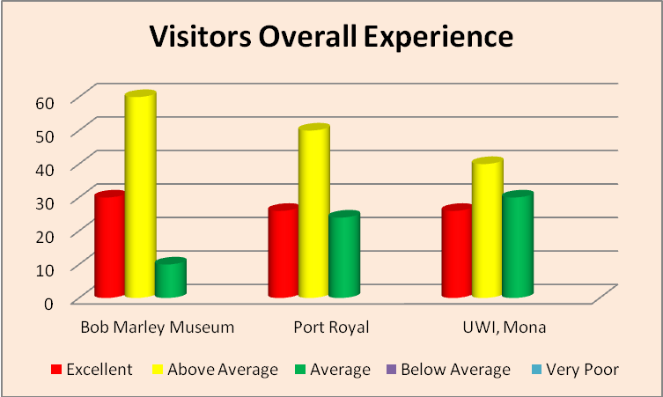
All three heritage sites incur a cost to maintain each attraction and improve visitor experience. However, based on interviews done, the managers at these attractions confirmed that the cost to maintain them does not outweigh the revenue earned. For example, the ruins of the aqueduct at UWI, Mona has been in its original state since it was built in the 17th century and the Giddy House in Port Royal that was built in the 18th century. Even though many monuments require limited maintenance, the grounds of these sites need to be maintained to accommodate and appeal to their visitors. With this known, strategies are being put in place to promote these attractions more.
To attract visitors, Bob Marley Museum includes promotion on websites, promotional discounts during certain seasons and with work done through the Bob Marley’s Foundation. In the case of Port Royal, the representative from Jamaica National Heritage Trust was unable to speak much on the strategies to attract more visitors but mentioned more marketing of the attraction via the media to attract more visitors since most of them have mentioned learning about this attraction through family and friends. The University of the West Indies also has strategies in place to increase the promotion of this heritage attraction, especially to who they’d like to be their niche market, international visitors. These include firstly, obtaining the Heritage Attraction license from the Tourism Product Development Company so that the attraction can be marketed more both locally and internationally. There are also plans in place to use more technology to enhance the appeal of this attraction. One such plan is to have more interactive media such as digital tablets at the various points for visitors to get more in depth information at each point. Doing this will aid in obtaining more funds needed to properly house delicate artifacts and use more technology to showcase and sustain the attractions as best as possible.

How is technology utilised at the named sites?
Currently, technology is being used at all three attractions to not just showcase and enhance them, but also to preserve them for future use. Technology used in the tours at Bob Marley museum includes key cards to open doors for ease of access; audio devices such as connected to speakers used around the house and, in the Bob Marley theatre, a short documentary is shown to end the tour. Conversely, technology is not being used much for the Port Royal tours. The museum at Fort Charles has two (2) screens that should show a documentary about the events that took place in the past; these are currently not working. The theatre housed at the Old Naval prison which should be used to show a documentary, however, is currently under construction.
Similarly, UWI, Mona, does not use technology in the guided tours since the sites visited are mainly outdoor monuments and artifacts. The tour guides take visitors to different points of interest while telling them the stories surrounding them. Here, technology is used mainly in the museum. Technology is also used to market the attraction. This includes a DVD that is available for purchase by visitors and ads placed on UWI TVs strategically placed across the campus. There is also a website available on which one can find brief information on UWI, Mona’s history and basic information like contact information that they will use to book their tours.
There are no short term plans to use more technology in the tours at Bob Marley Museum and the Museum at UWI, Mona. According to a Campus Culture and Heritage Tour Manager, there are short term plans in place to use more technology in the outdoor tours though not much because of the concern that this may take away from the main aim of the tours and dampen the experience.
All visitors noticed technology being used at Bob Marley Museum to enhance the attraction. 60% saw this at UWI, specifically in the museum, while 93% of Port Royal’s visitors did not see technology being used. 30% agree that the use of technology would make Bob Marley museum more appealing/interesting, 93% agree for Port Royal and 86% for UWI, Mona.
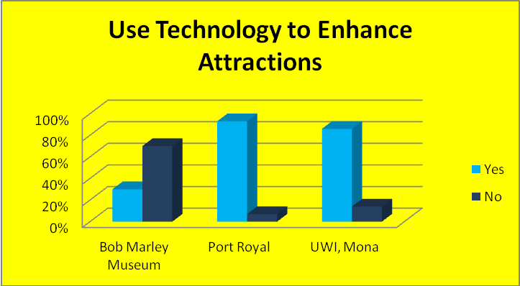

Challenges faced in sustaining the attractions
A few challenges are faced at all three attractions, not only with sustaining the attractions but with accommodating everyone who visits. For example, a tour guide at Bob Marley Museum stated that individuals in wheelchairs are not able to access the first floor of his house since they are unable to use the stairs. There are no ramps in place for them and a suggestion made to install an elevator could damage the building. At Port Royal, a cashier mentioned that one challenge is that of not having a debit/credit card machine at the attraction. She stated that some visitors mentioned that this is necessary since they would prefer to walk with less cash. The challenges being faced are being brought by staff members to the Jamaica National Heritage Trust to be addressed. While UWI, Mona did not express any challenge with e-commence, the attraction faces financial constraints in getting more updated technology to present information to visitors. To address this challenge, UWI plans to seek sponsorship from private entities to implement necessary changes.
There are not many short term plans in place to implement the use of more technology at Bob Marley Museum. Port Royal and UWI, Mona, on the other hand, have short term plans to increase the use of technology as a means of sustaining and enhancing their heritage tourism product.
To be able to use technology in a sustainable way, an increase in the entrance fee to these attractions may be necessary. As shown in the graph below, approximately 50% of visitors to each site expressed a willingness to pay an increased entrance fee if technology is used more to enhance the attractions. 80% of UWI, Mona’s respondent and 30% of Bob Marley Museum’s respondents would be willing to pay and increased entrance fee if technology is used to enhance these attractions.
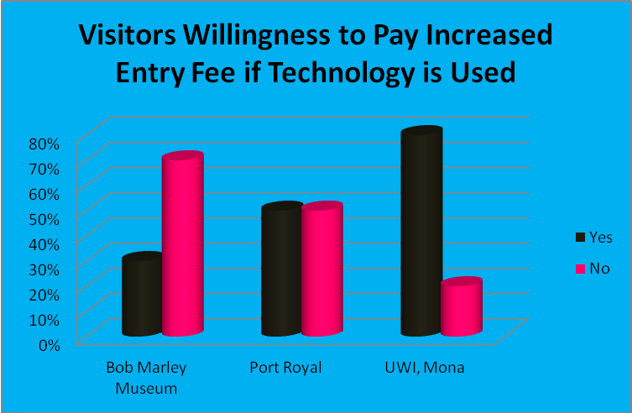
Overwhelmingly, all of the respondents indicated that they would visit the sites again, and would recommend all the attractions to their family and friends.

Discussion
Both Bob Marley Museum and Port Royal, two of Kingston’s top heritage tourist attractions see over 3,000 visitors each month. Some are repeat visitors who plan to return in the future and will recommend these attractions to family and friends. Bob Marley is said to be a household name that is continuously marketed both locally and internationally while Port Royal, once referred to as the wickedest place on earth, has many interesting stories of mercantilism and disasters. The University of the West Indies, Mona showcases heritage created during the plantation era and beyond but is marketed less and sees less visitors each month, approximately 300 in total. The reason for this is that the attraction is not yet licensed as a heritage tourism attraction by the Jamaica Tourist Board so they are not allowed to advertise heritage tours much in tourism accommodations and in the mass and digital media. Both Bob Marley Museum and Port Royal are licensed companies and are able to market the attractions more. There are short term plans in place to request the license so the University can advertise the product more both locally and internationally to increase its visibility and the number of visitors received. Increasing the visibility and attractiveness of these attractions promises to expand their earning potential and increase visitors.
These attractions represent and interpret different aspects of Jamaica’s culture and heritage. Interpretation goes beyond the physical structure of the buildings, to the way in which the tours are operated and how the artifacts are showcased. The Bob Marley museum represents the Rastafarian and reggae culture in several ways from the paintings on the premises to the statue at the front of the property, and even with the reggae music played there. Even the type of meals prepared in the café (referred to as ital where little salt is used and mostly natural seasonings) embodies reggae and Rastafarianism, appropriately interpreting Bob Marley’s heritage.
All three eras of UWI, Mona’s heritage may not be easily spotted upon entering the property since the campus now has a mixture of ancient architecture and modern structures such as a new state of the art medical science building. However, different monuments visible across the campus give an idea of what existed in the past. The ruins of the aqueduct that channeled water from the nearby Hope River to the sugar estates for example, represents the plantation era, several buildings currently being used as offices and labs represent Gibraltar Camp and Founders Park, that has tablets of significant dates and persons of interest represents the University College of the West Indies. These monuments have had little or no changes and are for the most parts left in their original state. The heritage product at this attraction can be interpreted in several ways based on how the tours are delivered.
Port Royal was a lively city in the 16th through 17th century buzzing with trade, parties in which there was drinking, prostitution and endless activities. Today, the town is very quiet. A tour of Port Royal is usually conducted by a tour guide who tells stories of the past, gives information on the monuments present and advise of their significance. One can get an idea of what Port Royal was like based on stories told but does not get a vivid experience through what the current environment offers of what really used to happen. Other than the current structures such as Fort Charles, the Old Goal/Naval Prison, St. Peters church, a few artifacts such as rum cups used, etc. there are not many visual aids available for visitors to see what Port Royal was like. As a result, the effectiveness of the tours and how Port Royal is interpreted are highly dependent on how it is shared by the tour guides. UWI, Mona is the attraction that had the youngest respondents with most being 18 years and younger though this may be so because of the time at which the surveys were done. This was at the end of summer, the beginning of the 2016/2017 school year when the first year students were being brought on campus tours. Bob Marley Museum and Port Royal saw more mature visitors between the ages of 20-50. This could be due to what they offer and how attractive these tours are presented to younger individuals.
Port Royal, which utilizes the least technology, had most persons stating they believe that technology can be used to enhance the appeal of the attraction. Currently, most visitors are interested mostly in the guided tours, showing that this may be the most fascinating aspect of the attractions. The tour guides do not utilize technology in these guided tour and visitors are required to use their imaginations to visualize descriptions. The main form of technology used at the Bob Marley Museum, the theatre that shows a documentary of his life, is said to be enjoyed by most visitors. A similar theatre would be ideal a Port Royal and could be used to show different films of documentaries for their different groups.
Using technology to enhance and sustain heritage tourism products will come at a cost. As shown above, several visitors are willing to pay an increased fee to enter these attractions with the anticipation of improved experiences with enhanced attractions.

Recommendations
All three heritage tourism attractions; Port Royal, Bob Marley’s Museum and The University of the West Indies Mona face challenges, some minor and others could be considered major. Based on information from members of staff, very few challenges are faced at these attractions and most visitors provide a positive feedback on their experience. For the few challenges faced, there are recommendations to address them with the aid of technology. These recommendations are seen as affordable, effective and will require no changes to any physical structure. These include the use of digital and interactive screens, using mobile applications, as well as 3D and 5D theatre, websites and social media and debit/credit card machines for payment.
- Use of Interactive Screens
The Bob Marley museum which was once Bob’s home is not structured to accommodate visitors with certain physical disabilities. According to a tour guide, installing an elevator is one recommendation made by a visitor who was unable to access the first floor in her wheel chair. It was explained however by a staff member that installing one would tamper with the originality of this building. Since no elevator can be built, the managers could consider installing interactive screens on the lower level of the museum, showing parts of the respective tours live for visitors with disabilities who are unable to access the upper floor.
For individuals with other disabilities, such as those who are deaf, technology could be used to cater to them and encourage their visit. To address the challenge of not having tour guides who know sign language to communicate with deaf visitors, digital screens could be used in different sections of the museum, with sign language videos and subtitles, to tell stories and share information. Accommodating visitors with disabilities is not just a concern for Bob Marley Museum, but one that has been shared by a deaf visitor who left a review on Trip Advisor (See Fig 1.0) about their trip to Fort Charles in Port Royal.
Fort Charles is a national heritage site currently managed by the Jamaica National Heritage Trust (JNHT). The museum on site however, is managed by the Institute of Jamaica. In the museum, only a few artifacts are currently displayed while others are housed at the Institute of Jamaica located approximately 23 kilometers/30 minutes drive away. The reason for this is the limited space available at the museum to showcase additional artifacts and there is not a way for visitors to view them while at Fort Charles. Inside the museum, there are 2 screens (See Fig 1.1) available that should be showing various documentaries of Port Royal. However, these are currently not working. The use of more advanced digital screens, similar to those used in the UWI, Mona’s museum can be used to showcase the artifacts that are not on site and other relevant information to enhance the visitors’ experience. The UWI, Mona museum currently has Apple screens showcasing the history of the university, one has the school song playing and there’s a television inside the museum where seats are provided (See Fig 1.5) to show a short documentary of the university’s history.
Port Royal also has several metal tablets (Fig 1.2) that give information on different historical events in Port Royal as well as information on the earthquakes that took place. These tablets give brief information that will be just enough for some visitors. Visitors who have in depth interest in the history of Port Royal would have to individually search for or request more information. Digital and interactive screens can also be used here allowing one to obtain more information in different formats much easier.
- The Use of Mobile Applications
According to Statista an online statistics portal, there are 4.61 billion mobile phone users worldwide in 2016 and this is forecast to reach 4.77 billion users in 2017. Our findings also showed that attractions that see younger visitors have a higher percentage of respondents who want to see technology being used more at these heritage attractions. Mobile devices and applications can be used in several ways to enhance these attractions while sustaining them.
  - Layar
The Layar application (Fig 1.4) is an augmented reality interactive media App that provides web links to more interactive media for scanned pictures or codes in campaigns created. This application or one similar can be used at attractions such as Port Royal and the University of the West Indies that have several built artifacts/monuments scattered over several acres of land.
This application would be ideal for use at the University of the West Indies that plans to use a bit more technology to enhance their heritage. Based on the nature of the Campus Heritage and Culture tours however, technology will not be used in all aspects of each tour with the concern that this may dampen visitors’ experience and eliminate the tour guides’ impact on how the attraction is interpreted. The campus currently has metal tablets similar to those at Port Royal that have limited information on the significant monuments. Both attractions can use this technology that allows visitors who would like more in depth information to use their smart devices to scan media or text created by the operators to access links provided for more information. The Layar application or other mobile applications that have similar capabilities such as QR Codes Creator and Reader can make this possible.
  - QR Codes (Quick Response Codes)
QR Code applications are very similar to the Layar application mentioned above. A QR Code is a type of matrix/two dimensional barcode that stores information in dots. They are relatively easy to create and can be scanned using several QR Code Readers available in mobile device stores for free downloads on the internet. Once a code is scanned using the Reader, a link will be displayed and when the user clicks this link they will be redirected to the information attached. This application, like Layar, would be ideal for use at all three attractions that have limited information displayed of some artifacts. It will assist with providing varying amount of information for different types of visitors and at their convenience.
  - Sparrowz- #Makeheritagefun
Having tours done in a more independent and fun way will make the heritage sites more attractive to children and teenagers that they see small numbers of. This could be done through games like scavenger hunts using mobile applications that are already being used in heritage attractions in countries such as Brazil.
According to the developers Indisparrow, the Sparrowz application allows gamification of city discovery through scavenger hunts. This application was used during the 2016 Rio Olympics in Rio De Janiero, Brazil encouraging visitors to learn about Brazil’s heritage while there. It would be ideal for attractions like Port Royal and UWI, Mona that have monuments and points of interest across several acres of land. Sparrowz was tested at the University of the West Indies recently during UNESCO’s International #MakeHeritageFun day on September 25th, 2016. Users are required to download the application on their smart phone and enter a password created by the event facilitator. They will then enable their GPS so they can be located after which they will receive clues to the points of interest. At each point, gamers will be required to check in or upload a photo to earn points and see information on each point. Winners are selected based on points earned and the time taken to complete the hunts, which is visible in the App and prizes are determined by the facilitator. This is a fun and interactive way of learning about a heritage attraction especially for the younger, tech savvy groups that visit.
- 3-Dimensional or even 5-Dimensional Films
Another recommendation that would be ideal for an attraction like Port Royal is showing 3-Dimensional or even 5-Dimensional films that enhance illusion, providing a real view of what is being shown. This can go beyond just watching the films with 3D glasses to having the 5D technology in which one feels the wind, heat, tremor and other special effects while viewing the events that contributed to Port Royal’s heritage. 3D technology is currently in Jamaican theatres and 5D technology is currently in an amusement centre in Kingston’s neighboring parish of St. Catherine. The theatre in Port Royal that is currently not being used can be upgraded to offer these technologies to significantly enhance the attraction’s experience while sustaining the heritage product.
- Websites and Social Media
All three attractions intend to use technology in marketing their products more. Currently, Bob Marley’s museum has a developed website and social media pages that are used to provide information, updates and feedback. UWI Mona’s website provides brief information on their history and on their heritage tours. A DVD is sold also and advertisements are shown on UWI advertising TV across the campus. Currently, Fort Charles at Port Royal is featured on Jamaica National Heritage Trust’s and Jamaica Tourist Board’s websites but has no media websites dedicated solely to market this attraction. The use of social media to share and market these attractions is a highly recommend cost effective way of marketing these attractions for increased visits. Many visitors at the named attraction stated that they found out about them from family and friends and through school. Websites and social media platforms like Facebook, Instagram, Twitter, etc can be used as marketing tools to reach a wide range of existing and potential visitors. Through these platforms visitors will be sensitized on the significance of these attractions, relationships can be built between visitors and operators and experiences shared to encourage more visibility and visits.
- Use of Credit/Debit Card Machine
An entrance fee is charged for all the attractions, they also have a café and with the exception of Fort Charles, a gift shop. A recommendation made by a member of staff at Fort Charles was to have a debit/credit card machine for the attraction that currently does not have one. She stated that this is a request made by visitors, especially those visiting with groups who prefer to not travel with a large amount of cash. Bob Marley Museum and UWI, Mona already have this technology available and it is highly recommended for Fort Charles especially with their intention of increasing the use of technology that may attract additional charges.

Conclusion
Jamaica’s tourism industry is highly focused on ‘sea, sun and sand’ that’s mainly used to market ‘Brand Jamaica’. The north coast sees scores of visitors each year who come to enjoy our tourism industry, a very sensitive one that depends highly on our natural environment. Kingston, the capital city of Jamaican and its outskirts are not usually marketed as a tourist destination even though this area is described as the centre of rich culture and heritage. Kingston, St. Andrew and Port Royal were focused on to see how technology can be used to develop and enhance Kingston’s Heritage Tourism product. Also assessed were the cost and benefits of sustaining Kingston’s heritage tourism as well as the sustainability of the technology supported by heritage tourism.
All three attractions involved; Bob Marley Museum, Fort Charles in Port Royal and the University of the West Indies (UWI), Mona were visited and both visitors and staff shared their views on these attractions through surveys. These attractions are national heritage sites that to be left in their original state eliminating the need for much costly maintenance. They are visited by locals and international visitors of varying age who come for various reasons including educational and recreational. Their stories from different eras of the past are unique to them and continue to attract visitors. With the increased use of technology globally, many countries are maximizing on the opportunities presented to develop and share their history and culture. Visitors and operators see where technology can be used to further develop our attractions locally and also to sustain them. Technology not just used to enhance tours and how these attractions are displayed but also how they are interpreted and marketed and preserved. In assessing the cost/benefits of increasing the use of technology, more visitors are willing to invest more financially which will assist with sustainability.
References
Biography.com Editors. (2016, November 25). A&E Television Networks. Retrieved from
http://www.biography.com/people/bob-marley-9399524

Bob Marley. (n.d.). Retrieved September 16, 2016, from http://www.bobmarley.com/history/

Bonarou, C. (2011). Heritage Tourism and Museum Management. Lesson 3: Tourism, Heritage
and Heritage Tourism (2nd Part). Retrieved from file:///C:/Users/user/Desktop/3_HeritageTourism&MuseumManagement.pdf

Buckley, D. (2005). The Right to be Proud: A Brief Guide to Jamaican Heritage Sites. Oxford,
Oxford University Press.

Christou, E (2005) Heritage and Cultural Tourism: A marketing-focused approach

Cooper, C., (2011, May 15).Bob Marley’s Fiery Legacy, The Gleaner. Kingston Jamaica

Dallen J. T. & Boyd, S. W. (2006). Heritage Tourism in the 21st Century: Valued Traditions and
New Perspectives, 1(1). Retrieved from http://dx.doi.org/10.1080/17438730608668462

Fort Charles (2011). Retrieved September 20, 2016, from
http://www.jnht.com/site_fort_charles.php

Garrrod, B, & Fyall, A. (2000). Annals of Tourism Research. Elsevier, 27(3), 682–708.

Hill, K. (2015, April 16). A Visit to Bob’s House. The Gleaner. Kingston Jamaica

Jamaica Information Service: Jamaican Heritage Site. Retrieved from:
http://jis.gov.jm/information/jamaica-heritage-sites/

Keegan and Atkinson. (2006). The Development of Jamaica Prehistory. In the Earliest
Inhabitants: The Dynamics of the Jamaican Taino, edited by L.G. Atkinson. Kingston Jamaica: University of the West Indies Press

Laws, E. (1998), Conceptualising visitor satisfaction management in heritage settings: An
exploratory blueprinting analysis of Leeds Castle, Kent. Tourism Management 19 (6), 545-554.

Moskowitz, D.V. (n.d.). Bob Marley: A bibliography. Westport, Conn : Greenwood Publishing
Group 2007

Moskowitz, D.V. (n.d.). The Words and Music of Bob Marley. Westport, Conn : Greenwood
Publishing Group 2007.

National Museum Jamaica. http://museums-ioj.org.jm/?p=317 Web retrieved Sept 16, 2016

National Trust for Historic Preservation.http://www.preservationnation.org/information-center/economics-of-revitalization/heritage-tourism/?referrer=https://www.google.com.jm/#.V7JokfkrLIU Web retrieved Oct 20, 2016

Poria, Y., Butler, R. & Airey, D. (2004). Links between Tourists, Heritage, and Reasons for
Visiting Heritage Sites, 43(1), 19–28. https://doi.org/10.1177/0047287504265508

Port Royal. (2011). Retrieved September 16, 2016, from
http://www.jnht.com/site_port_royal.php

Richards, G. (1996). Cultural Tourism in Europe. Wallingford: CAB International

Schon, D. A. (1967). Technology and Change : The Impact of Invention and Innovation on
American Social and Economic Development; The New Heraclitus. New York : Dell Publishing Co.

Smith H. (June 27, 2015). People’s Report Wow Experience At Bob Marley Museum, The
Gleaner. Kingston, Jamaica

Trotzig, G. (1993). The New European Convention on the Protection of the Archaeological
Heritage, Antiquity 67.

Sigala, M. and Leslie, D. (2005). Chapter 1: Heritage and Cultural Tourism: A Marketing-
focused Approach. In International Cultural Tourism Management, Implications and Cases. UK: Elsevier Ltd. Retrieved from https://books.google.com.jm/books?hl=en&lr=&id=lmEeJb9rySYC&oi=fnd&pg=PA3&dq=Christou,+E+(2005)+Heritage+and+Cultural+Tourism:+A+marketing-focused+approach&ots=BkMVpCEIys&sig=82SAWbjaytPvdMbWIJdb9tRh9pk&redir_esc=y#v=onepage&q&f=false

Strange T. & Bayley, A. (2008). Sustainable Development: Linking Economy, Society,
Environment. Paris: OECD.

Surugiua, M. R. & Surugiua, C. (2015). Heritage as an Alternative Driver for Sustainable
Development and Economic Recovery in South East Europe. Elsevier Ltd, 188, 74–81.

Tortello, R. (2005). Gibraltar Camp a Refugee from War. The Gleaner. Kingston Jamaica.

Traveling Towards A Global Sustainable Future: Sustaining Tourism. Retrieved from
http://www.sustainabletourism.net/

United Nations Educational, Scientific and Cultural Organisation: Convention Concerning the
Protection of the World Cultural and Natural Heritage: WHC-12/36.COM/5E Paris, 11 May 2012

University of the West Indies History (n,d) Retrieved September 26, 2016 from
http://www.mona.uwi.edu/economics/publications/content/history?qt-historic_site=3

UNWTO technical manual: Collection of Tourism Expenditure Statistics" (PDF). World
Tourism Organization. 1995. p. 10. Retrieved 26 March 2009.

Walsh, k. 1992. The Representation of the Past. Museums and Heritage in the Postmodern
World, London: Routledge.

Weiler, B and Hall, C (1992) Special Interest Tourism, London: Belhaven Press

Yale, P. (1991). From Tourist Attractions to Heritage Tourism. London: ELM Publications.

Appendices
Appendix 1: Sample Questionnaires
Instructions: Please place a tick in the box next to the answer of your choice or write your responses in the space provided.
Visitors
- Age
1. 18 and under 2. 19-29 3. 30-39 4. 40-49 5. 50 and older
- Sex
1. Male 2. Female

- Nationality? _________________________________

- On average, how many times per year do you visit cultural/heritage attractions?
- 1-2 times 2. 3-4 times 3. 5-6 times 4. more than 5 times

- Is this your first visit to this attraction?
1. Yes 2. No

- How did you find out about this cultural/heritage attraction?
- School 2. Internet 3. Family/Friends 4. Radio/TV e. Other

Please indicate how you feel about the some features of the attraction by using the following scale: 1. Very satisfied; 2. Satisfied; 3. Neither; 4. Dissatisfied; 5. Very Dissatisfied

 | Very satisfied | Satisfied | Neither | Dissatisfied | Very Dissatisfied
- The manner in which this attraction is being advertised and promoted
- The amount information given during the tour
- The amount of artefacts showcased
- The manner in which the artefacts are displayed

- How would you describe the overall experience at this cultural/heritage attraction?
1. Excellent 2. Above Average 3. Average 4. Below Average 5. Very Poor
- Was technology used to enhance any aspect of the attraction?
1. Yes 2. No
- Would the use of technology make this attraction more interesting and appealing?
1. Yes 2. No
- If technology is used to make the attraction more appealing, would you be willing to pay an increased entrance fee?
1. Yes 2. No

- Would you visit this attraction again?
1. Yes 2. No
- Would you recommend this attraction to a family or friend?
- Yes 2. No
Appendix 2: Curators/Staff
Instructions: Please place a tick in the box next to the answer of your choice or write your responses in the space provided.
- On average, how many visitors do you have on a monthly basis?
1. 0-100 2. 101-1000 3. 1001-2000 3. 2,000 -3000
- Are most of these visitors local or international?
1. Local 2. International
- Do you offer different types of tours and attractions?
1. Yes 2. No
- If so, how many types of tours do you offer? ___________________
- Are there different tours for different age groups/focus groups?
1. Yes 2. No
- Do you use technology in your tours?
1. Yes 2. No
- If yes, how is technology currently being used to enhance visitor experience?
__________________________________________________________________________________________________________________________________________________________________________________________________________________________________________
- How have visitors responded to the use of technology at this attraction?
1. Very Good 2. Good 3. Fair 4. Poor 5. Very Poor
- Are there any short term plans to use more technology at this attraction?
1. Yes 2. No
- What aspect of the attraction do visitors find most interesting?
1. Artifacts 2. History 3. Guided Tour 4. Other ____________
- Does the cost to maintain and market the museum outweigh the revenue earned?
1. Yes 2. No

- Are there strategies in place to increase the promotion of this attraction?
1. Yes 2. No
- If yes, what are some of these strategies? __________________________________________________________________________________________________________________________________________________________________________________________________________________________________________
- Are there plans in place utilize technology to enhance the appeal of this attraction?
1. Yes 2. No
- If so, what are the plans in place to implement the use of more technology to enhance visitor experience?
__________________________________________________________________________________________________________________________________________________________________________________________________________________________________________
- What are some of the challenges faced in sustaining this attraction?
__________________________________________________________________________________________________________________________________________________________________________________________________________________________________________
- What plans do you have in place to address these challenges?
________________________________________________________________________________________________________________________________________________

Appendix 3

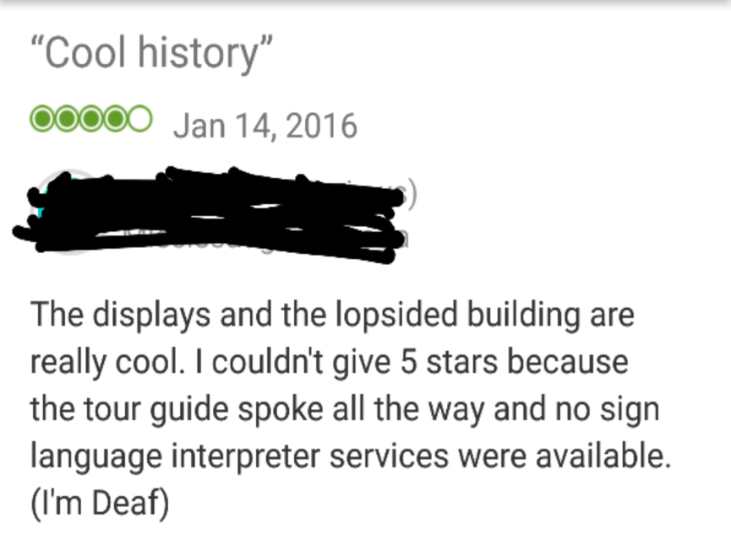
Figure 1.0

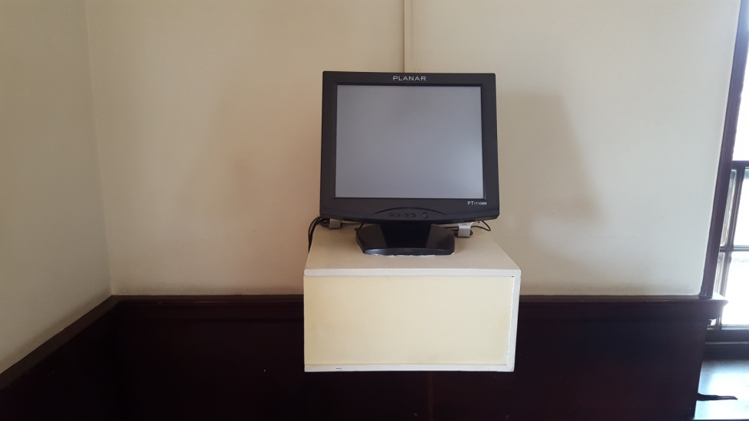
Figure 1.1
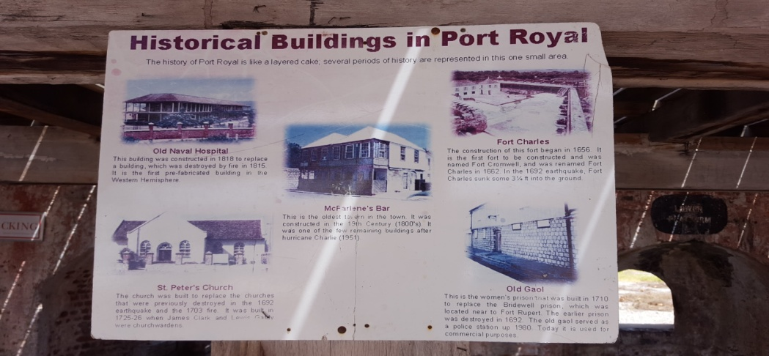

Figure 1.3

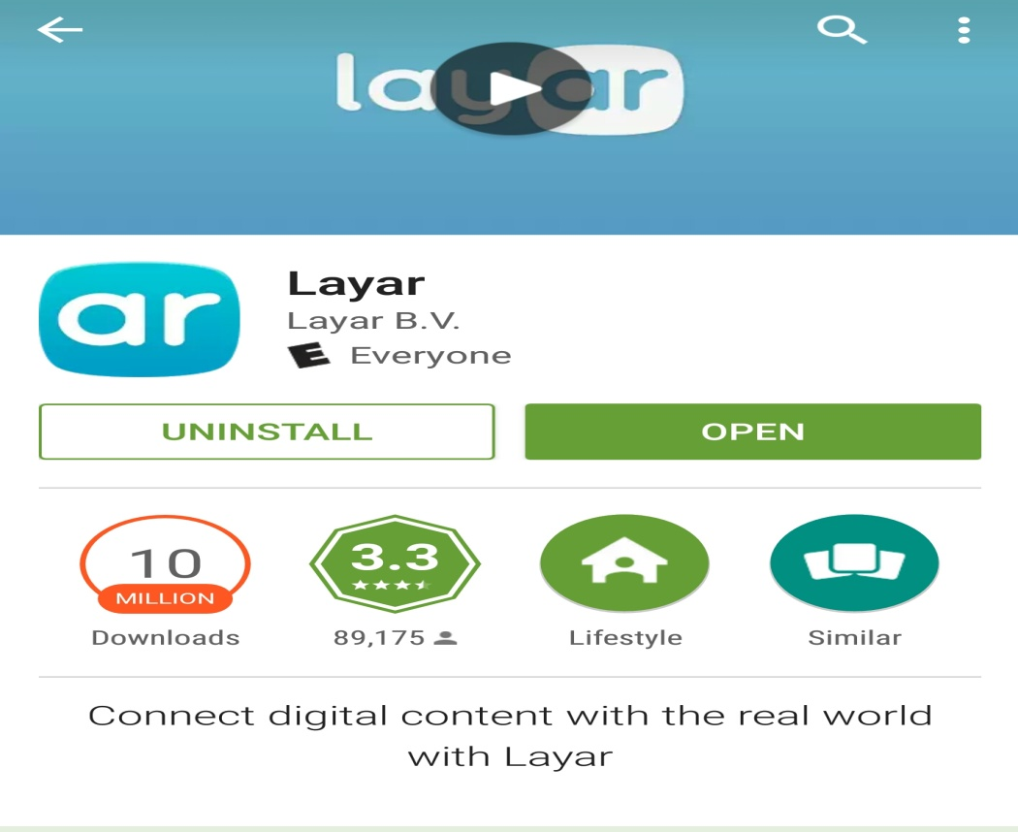

Figure 1.4



